Text Analysis: A Comparison Between Naïve Bayes and Support Vector Machines
Kent Roller

Introduction
The importance of text data and the increase of its accessibility has been covered exhaustively. Benefits of performing sentiment analysis on eligible text data bases are many for companies able to leverage this advantage. Methods behind the scene are never mentioned as frequently as the results are showcased, which can leave some questions as to how to best approach extracting meaningful data or producing systems that can make use of the data in a meaningful way (i.e. prediction). Two such methods used for text analysis are Multinomial Naïve Bayes and Support Vector Machines. Each of these methods, as with most models, have their inherent strengths and weaknesses. Since this is the case, a comparison will be made to identify which of the methods is more perfomant with the task at hand.

Models
Comparisons between the models are being made due to their usability with text type data sets. The Multinomial Naïve Bayes model, as the name implies, leverages the Bayes theorem to calculate the probability a word belongs to a certain class based on the probability that the other words that make up a complete phrase are also in the same class. The Naïve component in MNB is that the model assumes that the word occurrences are independent of one another in a given class. MNB is adept at handling new data once trained to be a good model. Support Vector Machines on the other hand, rely on their higher dimensionality to find hyperplanes with which to separate classes. The more points that lie on the margin of the hyperplane, the better the performance of the model. All points residing on the hyperplane would indicate overfitment of the model. The high dimensionality allows SVM to apply linear solutions to non linear problems.
The data is comprised of movie reviews provided via Kaggle, from a competition hosted on the site. While the competition is at this point long over, the data can still be used in order to make a comparison between methods. The data set consist of two columns, “Sentiment”, which contains labels for the data ranging from 0-4, representing “very negative” to “very positive” respectively and the column “Phrase”, which contains the text representing the movie review. Further, the data is split on the Kaggle source between training data and testing data, where each is contained in its own file. The data is predominantly composed of “Neutral” ranked reviews, followed by "Positive” and “Negative” at around half the frequency of neutral, and lastly “Very Negative” and “Very Positive” reviews which are around one quarter of the total frequency of the “Positive” and “Negative” reviews. If plotted it would closely resemble a normal distribution, though, depending on the model a uniform distribution between classes may be more desired. Next the several vectorizers were setup to accommodate a variety of comparisons between models. The first comparison between Multinomial Naïve Bayes models and Support Vector Machines was made using vectorizers that only considered unigrams in the vectorization process. This means that the words will only be considered by themselves and not part of a word phrase (neighboring words provide no significant relation to target word). Once both models are compared using unigrams only, a second comparison will be made which will compare the performance of unigram only models to models that incorporate both unigrams and bigrams. In this case, both the single words and potential phrase words will be considered in the model to determine if a difference exist. Lastly, hyperparameters will be tuned for the SVM model in order to try and gain greater performance out of the model, if possible.

Results
For the first comparison a unigram only vectorizer was used to prepare the data. Then both the MNB and SVM models were used on the data, and performance measures were taken to assess the capabilities of each. A word list was generated for each of the models for both the very positive and very negative sentiment labels.
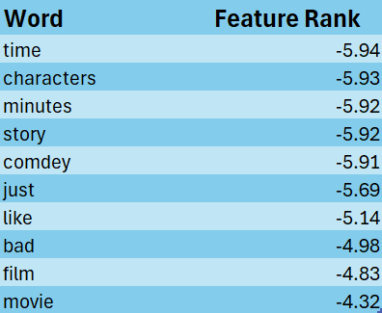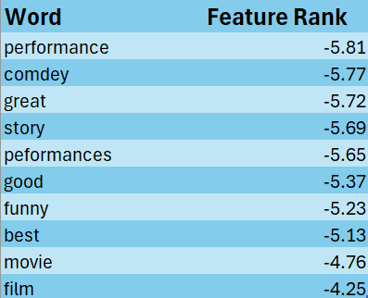
Fig 1.1 Very Negative MNB Fig 1.2 Very Positive MNB
Figures 1.1 and 1.2 show the top 10 words for both the Very Negative and Very Positive Labels using the Multinomial Naïve Bayes model. Here some of the words such as “bad” or “great” seem to fit into their category rather neatly, though the same cannot be said for observation such as “like” or that “movie” and “film” appear in both label sets, indicating a poor performing top word. This can be compared to similar tables produced by the SVM model using the unigram vectorizer.

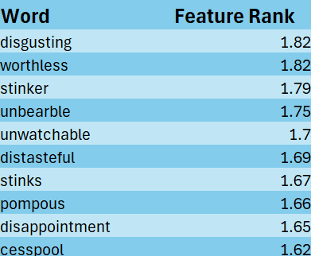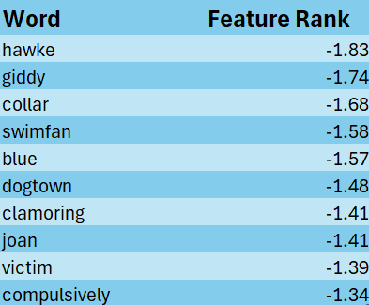
Fig 1.3 Very Negative SVM Fig 1.4 Very Positive SVM

In figures 1.3 and 1.4 the top 10 words for the very positive and very negative sentiment labels using the SVM model can be observed. Here, a stark contrast can be seen between the word list generated by the SVM model and the one generated by the MNB model. The most noticeable difference being that none of the list within the same label group share the same words across models. What’s more, the SVM model seemed to have selected more meaningful word choices than the MNB as words like disgusting or clamoring are much more indicative of how a person may have been feeling about the movie rather than what they had liked/disliked about the movie, highlighted by the models selections for word like time versus unwatchable for the very negative label. This in of itself does indicate which is the overall best performance model, but may highlight a reason to pick one model over another depending on what in the review you wanted to focus on (cause or effect) (explanation vs emotion)
Next, we take a look at the confusion matrix generated by each of the models to compare how they performed across each label and if one model was the clear winner.

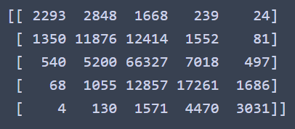
0 1 2 3 4
Fig 1.5 Confusion Matrix for MNB
In figure 1.5 the confusion matrix for the MNB model can be seen , along with each of the class labels, 0-4, where 0 represents Very Negative and 4 represents Very Positive. As is expected, due to having the largest number of observations in the dataset, the Neutral label has the highest number of correct predictions. This is followed by positive and negative labels which had the second largest number of observations in the dataset.

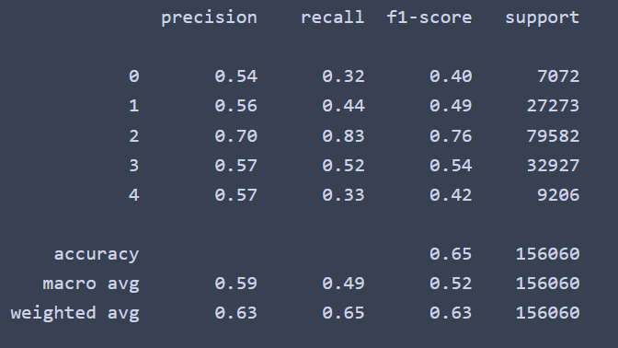
Fig 1.6 Classification report for MNB
Figure 1.6 shows the classification report for the MNB utilizing only unigrams. As expected by the output shown in the confusion matrix, the overall weighted precision is 63%, with a recall of 65% and a f1-score of 0.67. The overall accuracy for the model was 64.58%

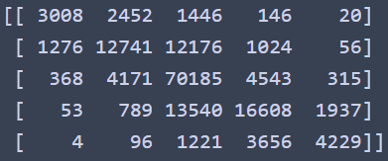
0 1 2 3 4
Fig 1.7 Confusion Matrix for SVM
Figure 1.7 shows the confusion matrix for the SVM model using unigrams. As can be observed in the matrix, the uplift in performance compared to the MNB model in minimal in the Neutral label, however, the model seems to have performed quite a bit better in the more extreme observations or those with lower total observations such as Very Negative or Very Positive. This indicates that the difference in word selection may have an affect on the overall performance of the model.
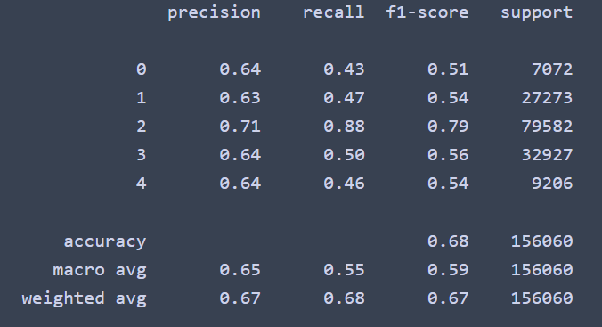
Fig 1.8 Classification Report for SVM
Figure 1.8 shows the classification report for the SVM using the unigrams only. As seen in the confusion matrix, the SVM did indeed perform better in labels 0 and 4, while showing only a minimal uplift in the Neutral label. The average weighted precision came in at 67%, a 4% uplift over the MNB model, 68% recall, and 0.67 f1-score. The overall accuracy of the SVM model was 68.42%, a ~4% uplift overall from the MNB model.

To test how of a difference in the final model the inclusion of bigrams make, we will now perform the same task as above, though this time, instead of using only unigrams in the vectorizer we will allow for both unigrams and bigrams to be passed through the vectorizer. It should be noted that performance measures here should not be considered a general observation of how bigrams can influence models, as their influence will be data and model dependent.

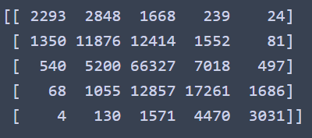
0 1 2 3 4
Fig 1.9 Confusion Matrix for MNB Unigram and Bigram
Figure 1.9 shows the confusion matrix for the MNB model using both unigrams and bigrams within the vectorizer. The matrix is aptly named, as confusion is the result of this output. The values are identical to the values shown in the confusion matrix. There are a couple of reasons why this may be the case. The first is that the data does not contain any instances of bigrams that have a meaningful impact on the sentiment analysis, and as such, their inclusion is meaningless. The second is that bigrams are not used at all in the review text so that there is no effect with including them.***

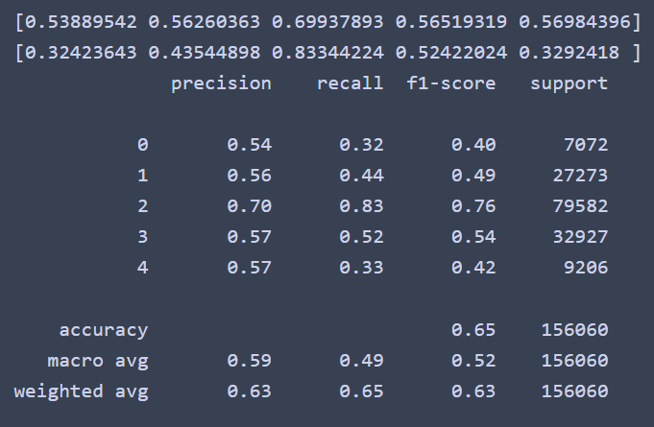
Fig 2.0 Classification Report for MNB w/Unigrams and Bigrams
Figure 2.0 shows the classification report for the MNB model using both unigrams and bigrams. As seen in the confusion matrix for the model, the results are identical to the first pass indicating that once again there was no effect from including the bigrams. Next, we will see if SVM performed the same as before with the inclusion of the bigrams.

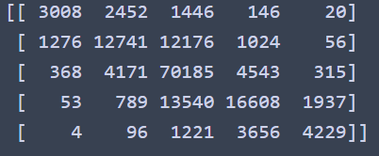
Fig 2.1 Confusion Matrix for SVM with Bigrams
Figure 2.1 shows the confusion matrix for the SVM with unigrams and bigrams. As with the MNB, there is no change in the performance of the model when compared to the unigram only model. This once again indicates that the data may be lacking meaningful bigrams in relation to the sentiment analysis.

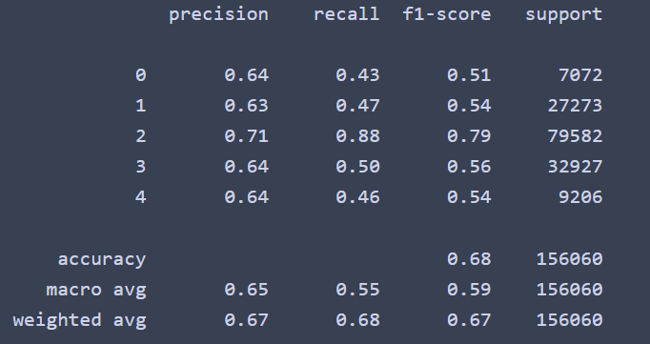
Fig 2.2 Classification Report for SVM with Bigrams

Figure 2.2 shows the classification report for the SVM model using both unigrams and bigrams. Once again the results are identical to the first pass of the model, as suggested by the confusion matrix, and mimicking the results of the MNB model, in terms of being the same regardless of using unigrams or bigrams. Next we will see if the performance can be improved over the original pass by tuning the hyperparameters. The hyper parameters tuned included C, which is a regularization parameter, which is basically how strict the model is about allowing mistakes. The higher the value, the less lenient, higher values tend to lead to overfitting of the model. Tol was also tested, which is a parameter for setting the tolerance for the stopping criteria of the model. We also tested the performance difference between having class weight set to its default or using ‘balanced’. The investigation of each hyperparameter was done via grid. For the initial pass of C, the values [0.050, 0.075, 0.1, 0.25, 0.35, 0.55, 0.75] were used. Out of these [0.05] performed the best at 55.46% accuracy, so another iteration was run this time with the values [0.015, 0.025, 0.035, 0.045, 0.065, 0.075, 0.085]. Here the best value was found to be [0.35] at 55.48%. A third iteration was run to test the value [1000] to see if purposeful overfitment would lead to a higher accuracy value, however here it performed worse than [100] a value removed in the first round. Next, Tol was tested with the following values [0.0001, 0.00001, 0.001, 0.01, 0.1, 0.000001], out of which, the value 0.1 performed the best, with an accuracy of 54.40%. Following the Tol adjustment, performance between leaving class weight set to default and using balanced was checked. Due to the distribution of the classes, using balanced class weights reduced the accuracy of the model when compared to using the default settings. Equipped with this, another SVM was made using the hyper parameter values that were found to be optimal. The overall accuracy for the model was 63.39%.

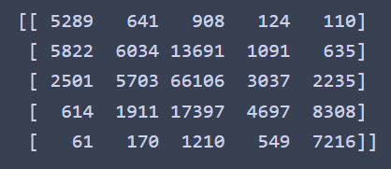
Fig 2.3 Confusion Matrix for Tuned SVM
Figure 2.3 shows the confusion matrix for the tuned SVM model. Looking at the confusion matrix, we can see a downturn in performance when compared to the original SVM model for the Neutral label. Likewise, both the positive and negative labels also suffer a performance degradation. But, the extremes, which SVM was better at in the initial comparison with MNB, once again appear to shine, as they see performance bump over the original SVM. 10-Fold Cross Validation was performed on the model, where an average accuracy of 55.12% was achieved across all folds.

Conclusion
Comparing models can lead to insights about how the model performs with a given data set. Depending on the data set and the overall goals desired, one model may offer the better option. For pure accuracy performance, SVM outclassed MNB. But when looking at the top 10 most very negative and very positive words it could be seen that the models operated differently. A result of this is that certain words are more important in the analysis depending on which model is used, which reflects the objective dependent nature mentioned previously. The inclusion of bigrams was tested, however it was found that this offered no noticeable performance gains. Hyper parameters of the SVM model where then tested to see if tuning of these parameters could yield better performance. On accuracy via scoring, the tuned model was slightly more performant that the non tuned model. Further performance could likely be gained with further curation of the pre processing and vectorization steps. All of this puts on display the fact that may models can offer performance straight out of the box, but often, tweaking of the model and the preprocessing will yield better results than out of the box models.

*** I have botched this assignment. I realize that the results are incorrect, and that they should be different from what they are. I have messed up in the application of the vectorization using bigrams and unigrams. I lost track of my variables and as a result I am calling the base vectorization method used over and over again explaining why the results are the same. Unfortunately, I am between a rock and a hard place, in either turning this in now or risk it being late. I have already pushed the date to “a couple of days” and do not want to push it any further. However, I have serious reservations about turning this in as the code is botched and the results are botched and as a result this report is basically useless. All I can say is this, I am sorry for turning this in, I know its trash, and that I am going to redownload the code and start from scratch. I can turn the revised version in at a later date. Not for an update to the grade but just as proof that I cant stand this and that it was fixed. Especially since I have already done this once in a previous assignment on my own. Again, I got lost trying to use the supplied code, it’s a mess, apologies.

